Required Coding Activity 12.4: Modify a Distributed Scalable Database in a Container

- Provide a screenshot of your Docker desktop showing the Cassandra container running in port 9042.
Pull the Cassandra Image:
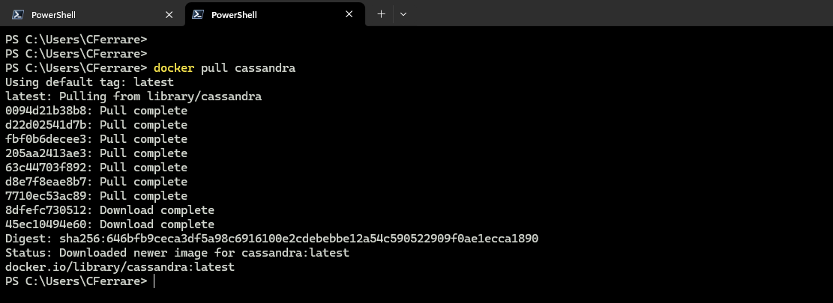

Create the Cassandra Container:
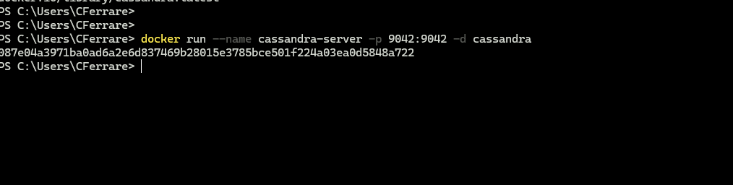

Cassandra Container Running on Docker Desktop:
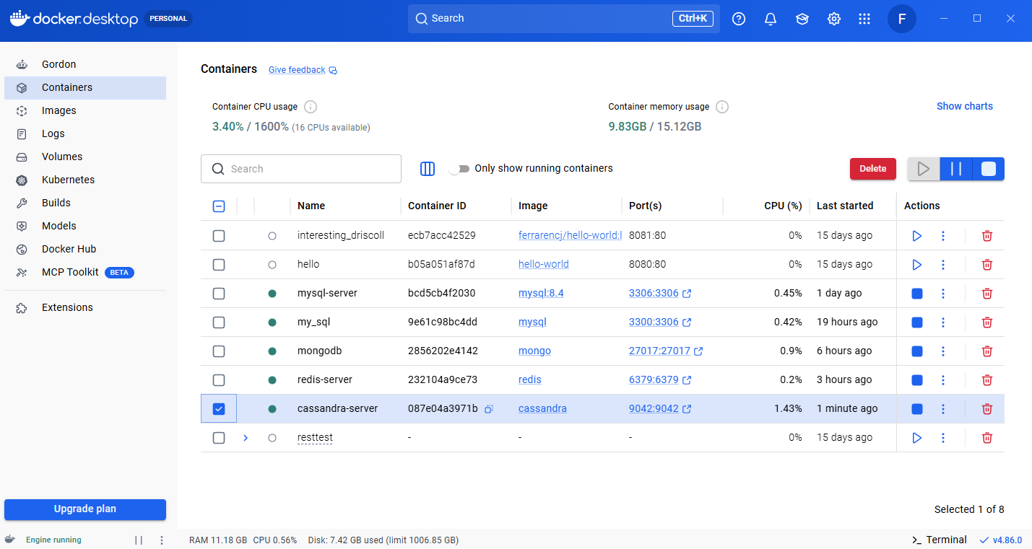

Open the Cassandra shell (cqlsh) from inside the container:
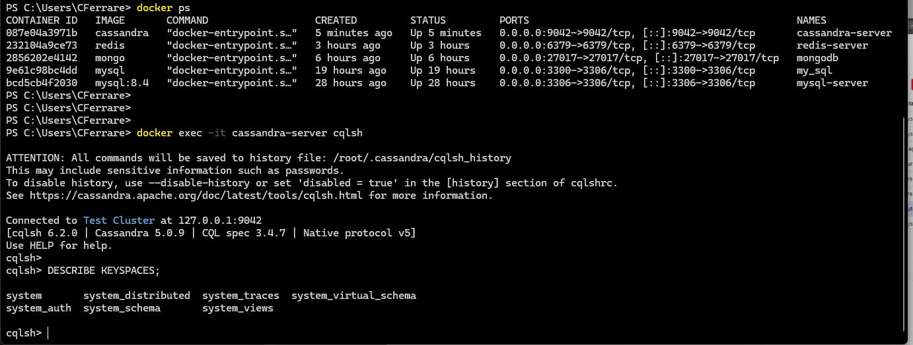

- Provide screenshots to show that the write.py file was created in VS Code and that it contains the following required elements:
- A keyspace called books.
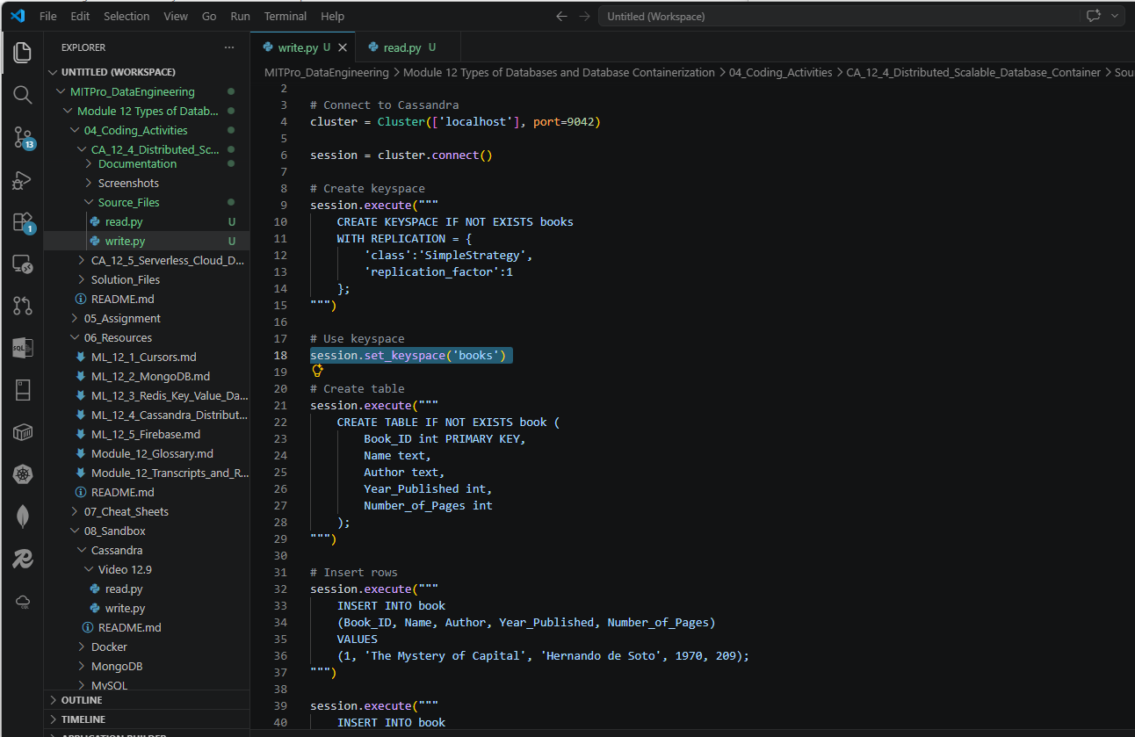

- A table called book that contains the columns and rows defined in the activity instructions.
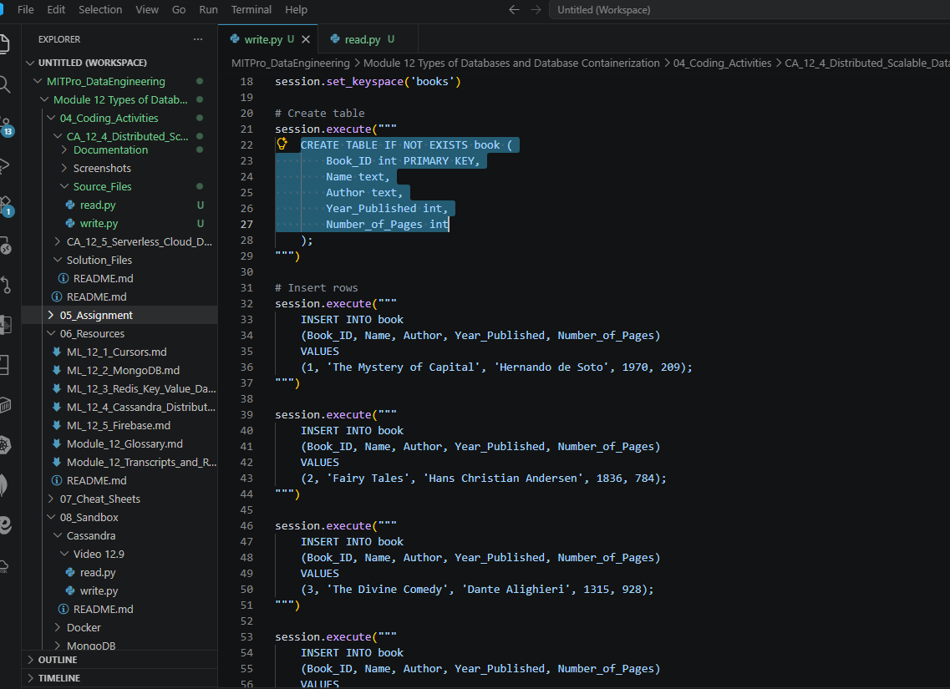
- Provide screenshots to show that the read.py file was created in VS Code and that it contains the four books within the books keyspace.
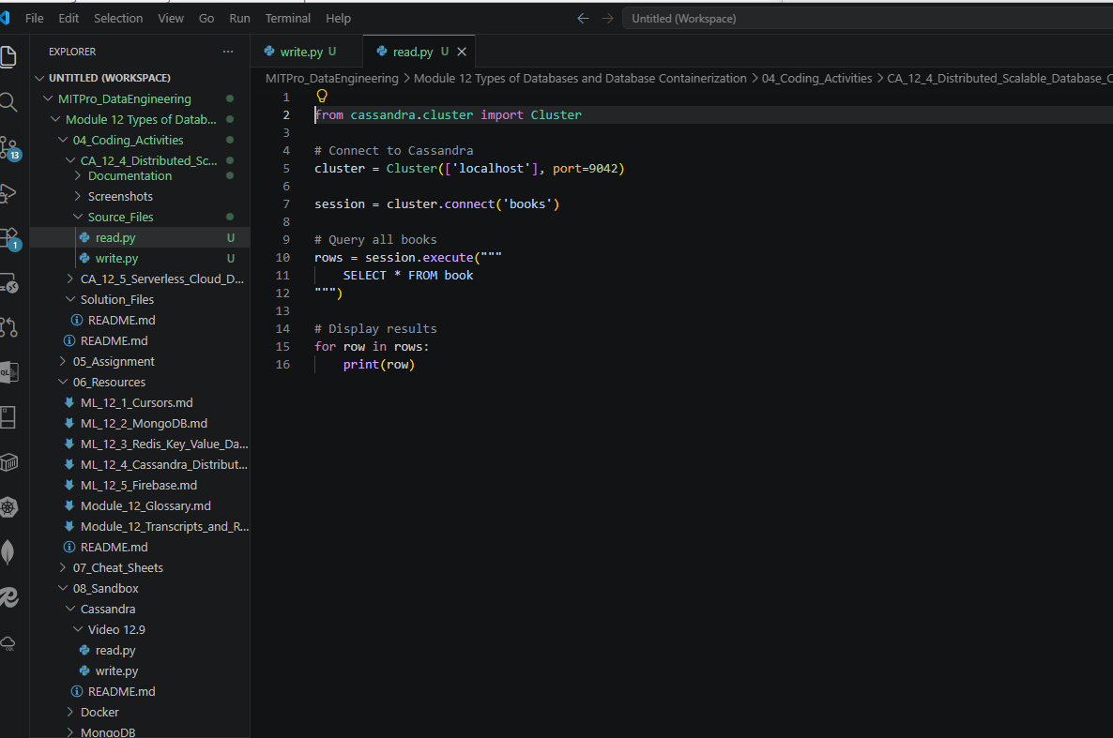

- Provide a screenshot of the cqlsh window to show that insert statement has been run to add the fifth book to the books keyspace.

Result of the write.py executed:

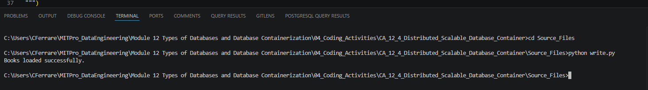

Cqlsh window:

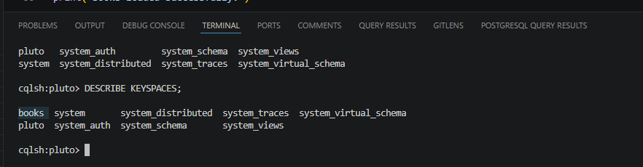

Workbench:
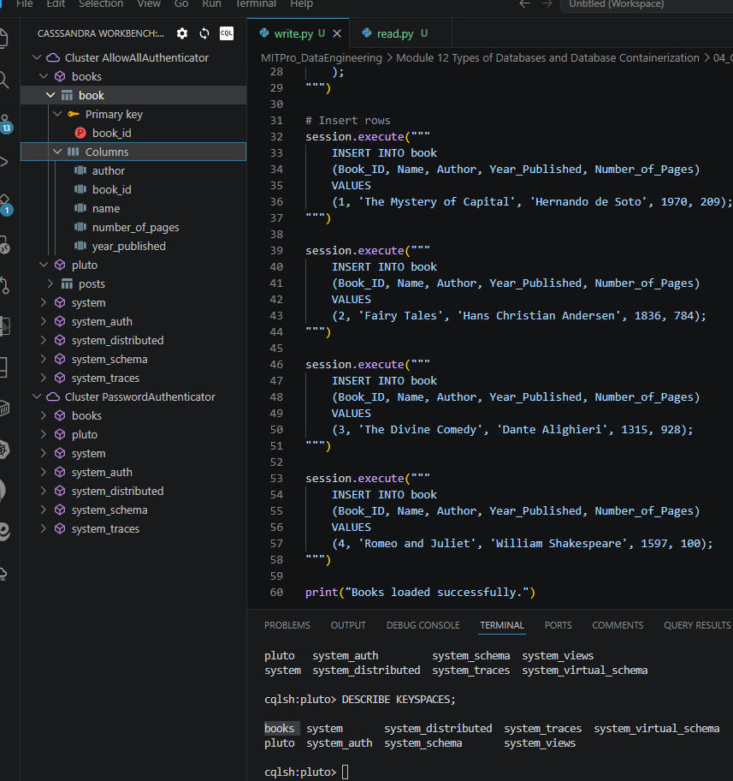

- Provide a screenshot of the cqlsh window showing the results of the SELECT statement with all books in the books keyspace selected.
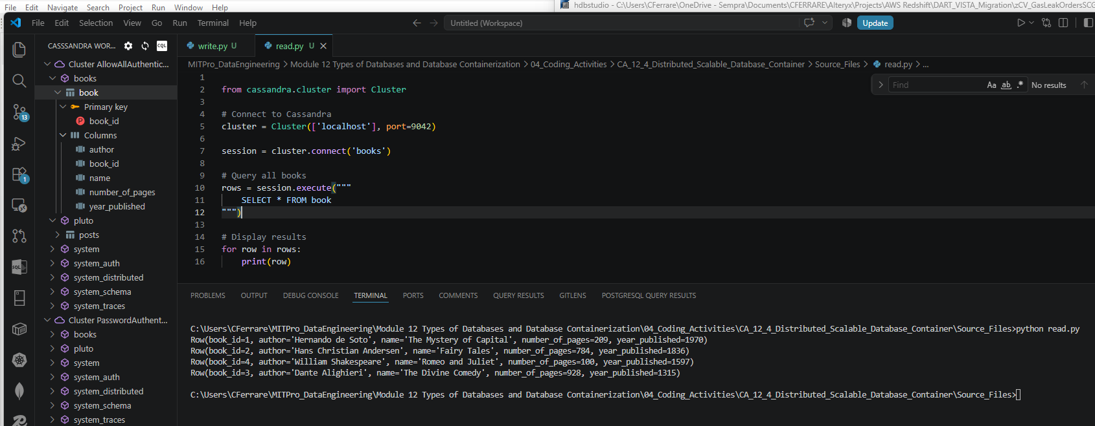

On cqlsh window:
